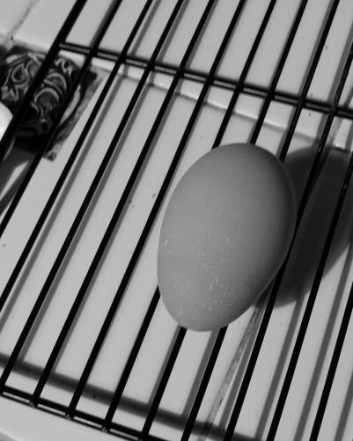

The first one is original egg, and the second one is basic scale (take certain points value from matrix converted from graph), which we can easily see the edges of the lines, and the third one is average scale(take the average number of each matrix points converted from graph), which we can find that the graph is smooth compared with the basic scale. So, if the original photo is low resolution, I will select basic scaling, but if the photo is high resolution, I will use the average scaling to scale that.

Assignment 4

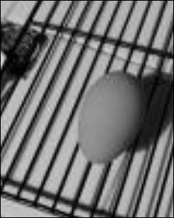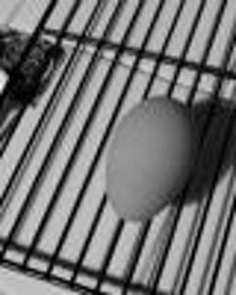

I select average scaling egg from previous exercise, because it is smooth. The second one is replication scale(occupy the empty space with same value), and the third graph is interpolation scale (use linear relations between two different point). From the graph we can kindly tell that the Interpolation scale is more clear that the replication scale. So if the graph is high resolution I will use replication scale to make a little bit smooth, otherwise, I use interpolation scaling.

Assignment 5

For the shrunk scale, I use the average scale for my photo(convolution of square matric with all 1 inside to convolve the whole photo to get the average scaling), for enlarge scale, I use interpolation scale (take the average between two nearest value and apply between them. For the average scale, there is obvious blur occurred, and the size is decrease by the factor of 5, and for the interpolation scale, the graph is sized up by factor of 3, and the graph seem smooth even its size increased.

**Original graph**



**Two scale graph( first average scale, second interpolation scale), we can find second photo isreally smooth because it perfectly make up the emplty spaces with the average number, and the first graph dose not have so much clear edges, because it uses the avergae scaling method to shrunk it.**

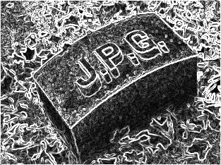

Blurring photo and edges detection photo